Ecommerce Data Analysis
Mini Project
Ajul Krishna K V

This retail e-commerce orders dataset from Pakistan contains approximately half a million transaction records spanning from March 2016 to August 2018. For the purpose of this project, the dataset was refined by filtering and sorting the records based on the Item_ID field, specifically selecting rows where Item_ID falls between 827100 and 829000. This subset was used for further cleaning and analysis to ensure focused and meaningful insights.
Data Source:
https://www.kaggle.com/datasets/zusmani/pakistans-largest-ecommerce-dataset

Business Goal:
This project aims to uncover meaningful insights from ecommerce order data to support better business planning and performance optimization.

Dataset:

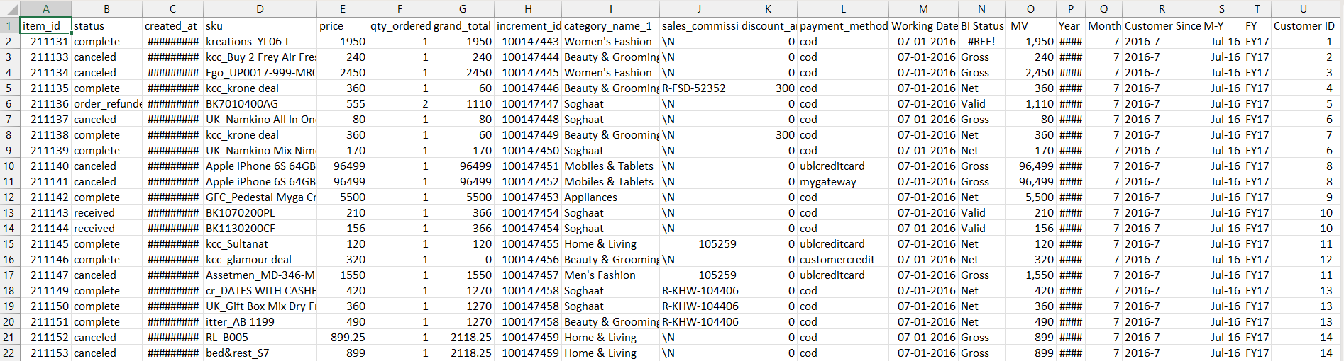

Before sorting,
- Total number of rows before cleaning: 584524
- Total number of columns before cleaning: 21
- Total number of blank cells: 137370
- No duplicates values are there in the dataset.

Data Cleaning

- To create a manageable subset from the original dataset containing over 5 lakh records, the Item_ID column was filtered to retain only the records falling between 827100 and 829000. This was achieved in Excel by applying number-based filtering on the Item_ID field (using the “Number Filters → Between” option), ensuring that only the relevant rows within the specified range were extracted while preserving all corresponding column values.

- Removed non-essential columns such as SKU, Increment_ID, MV, Year, Month, Sales_Commission_Code, Working Date, Customer Since, and M-Y, as these fields did not contribute meaningful value to the analysis.

- Standardized all date fields into a consistent dd-mm-yyyy format, as the dataset originally contained mixed date formats such as DMY and MDY, which could lead to misinterpretation during analysis.

- The Amount column was standardized by converting numeric values into currency format (e.g., 1950 → ₹1950.00) to improve readability and consistency in financial reporting.

Updated Dataset
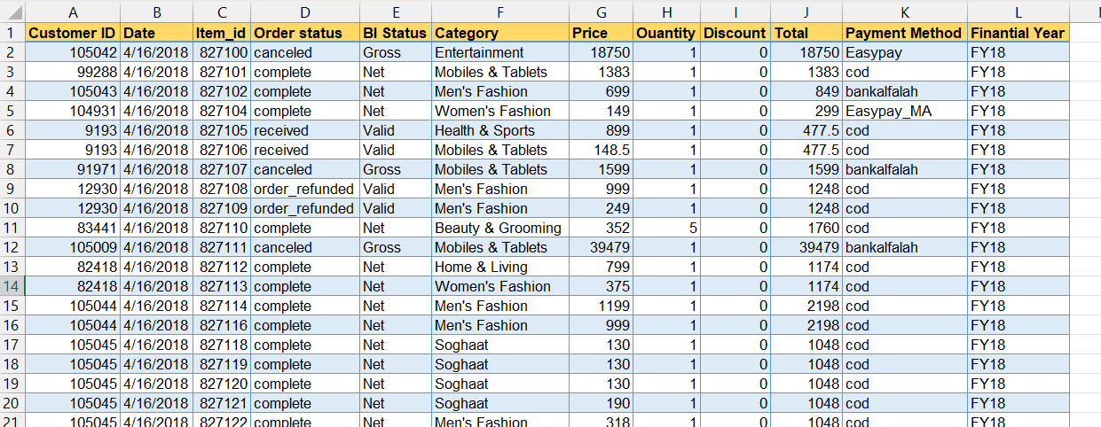

After sorting,
- Total number of rows: 1697
- Total number of columns: 12
- Total number of blank cells: 21 (Order status – 6, Category – 15)

- Standardized the values in the Payment Method and named as Payment Method Updated
      - Functions used
        - IF() and Proper()

=IF([@[Payment ]]<>"cod",PROPER([@[Payment ]]),"COD")

- Filled blank cells and standardized the text values in the Order Status column and saved the cleaned results as Order Status Updated.
        - Functions used
            - IF(), ISBLANK(), and PROPER()
=IF(ISBLANK([@[Order status]]),"Unknown",PROPER([@[Order status]]))

- Blank cells in the Product Category column were replaced with “Others” to ensure consistency and avoid missing classifications during analysis
      - Functions used
        - IF() and ISBLANK()

=IF(ISBLANK([@Category]),"Others",[@Category])

- Corrected calculation errors in the Total column by recalculating the payable amount using the formula: (Price × Quantity) − Discount. The updated and accurate values were stored in a newly created column named Payable Amount.

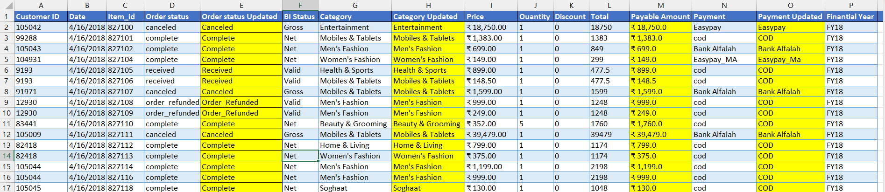
        - =([@Price]*[@Ouantity])-[@Discount

Cleaned Dataset
* Newly created columns are highlighted for quick reference.

Conclution

The project successfully transformed raw sales data into actionable business insights using Power BI. Through data cleaning, DAX calculations, and interactive dashboards, key revenue trends, top-performing products, customer contribution, and discount impacts were identified. The use of BI values (Gross, Valid, and Net) enabled transparent revenue tracking and strengthened data-driven decision-making for business stakeholders.

